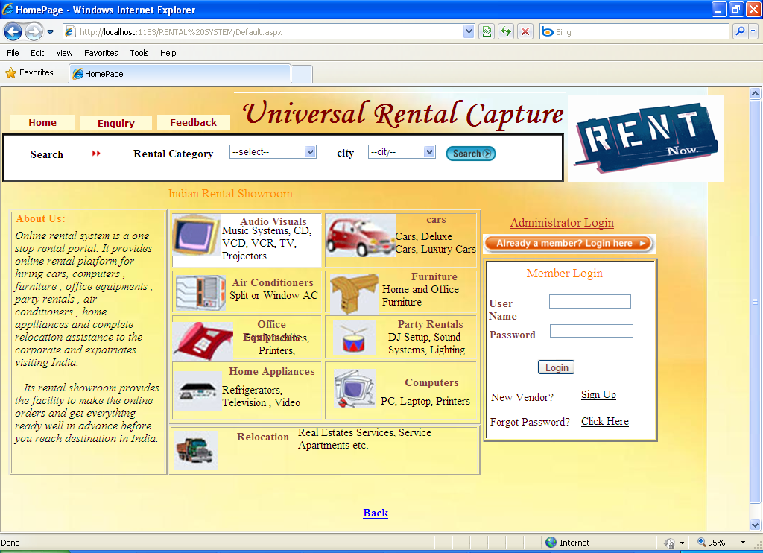

Pagename: home page

Fields: login,user,paaaword,signup,admin

Process: navigates to child pages,admin

Table: login

Remarks: enter into fields

Error: no

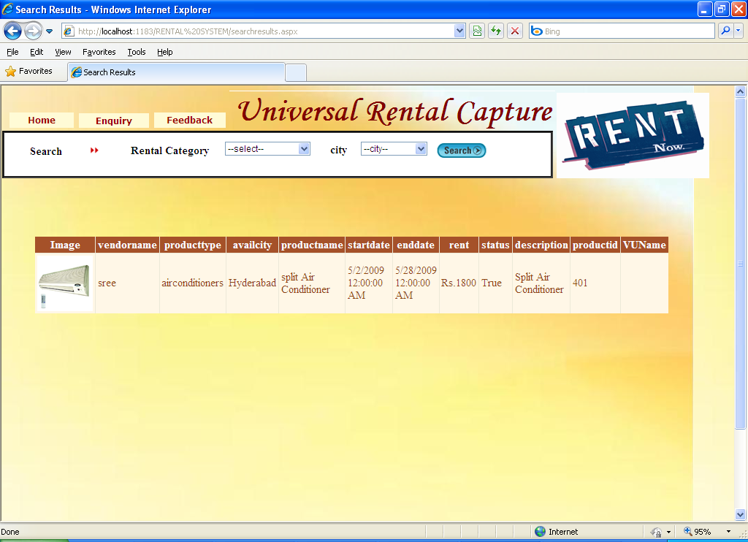

Pagename: search by

Fields: grid view

Process: we can search products by city



Pagename: home page

Fields: login,user,paaaword,signup

Process: navigates to member pages

Table: login

Remarks: enter into fields

Error: no

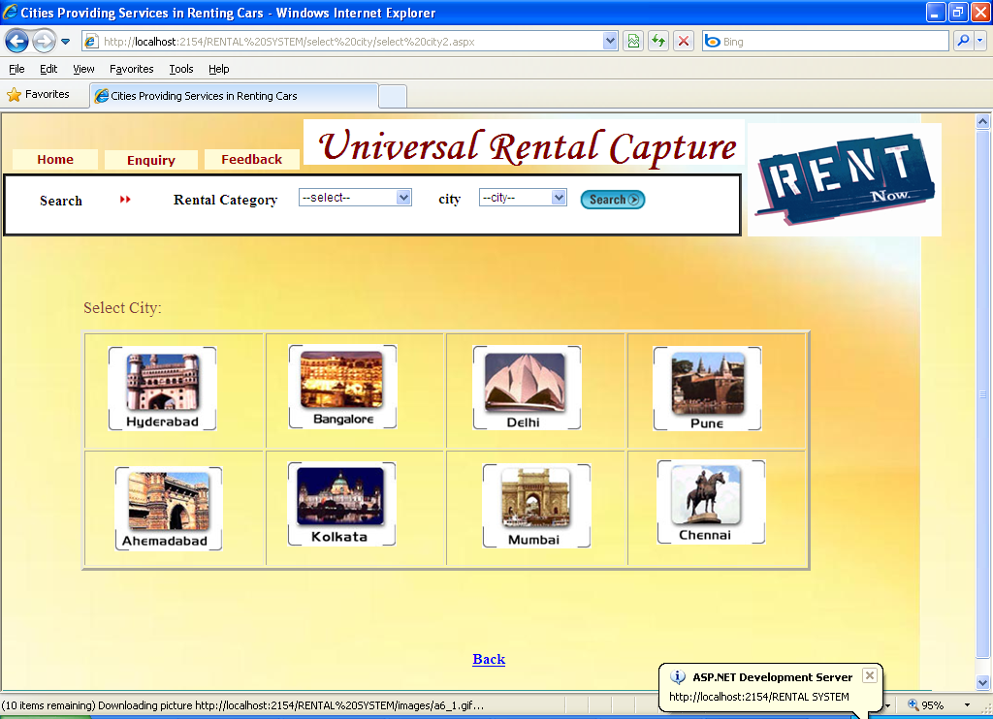

Pagename: select city

Fields: image controles

Process: we can select products by cities

Table: booking

Error:no

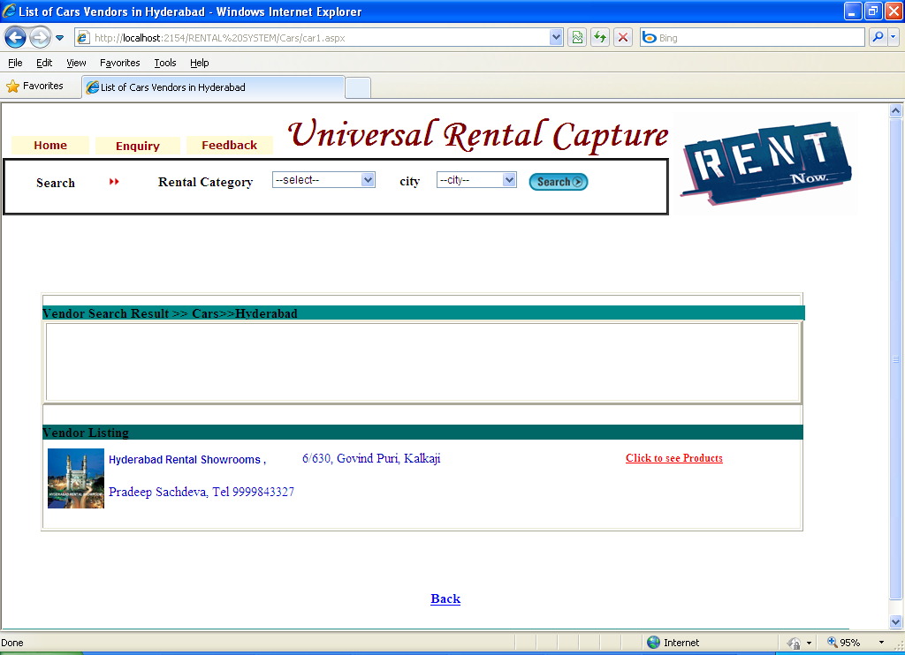

Pagename: vendor search results

Fields: click to see products

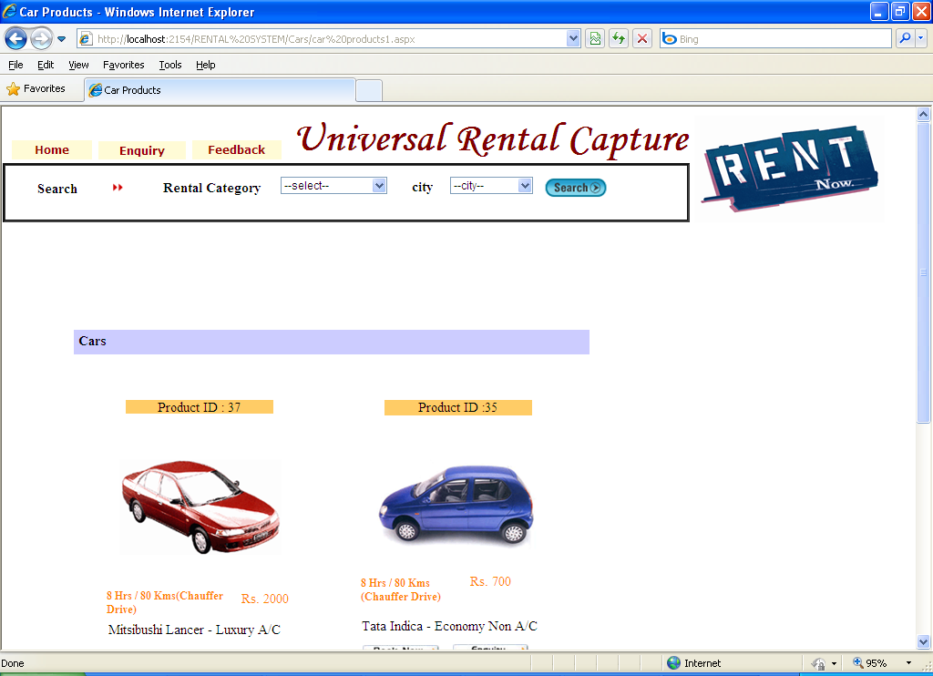

Pagename: vendor search results

Fields: click to see products

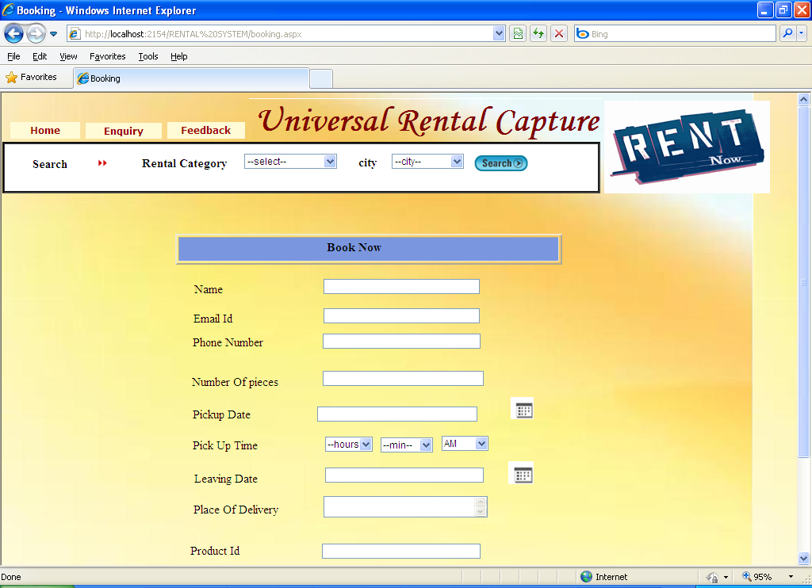

Pagename: booking

Fields: name,email,phone,no of,date,product id

Process: we can book for products

Table: booking

Remarks: enterinto fields

Error:no

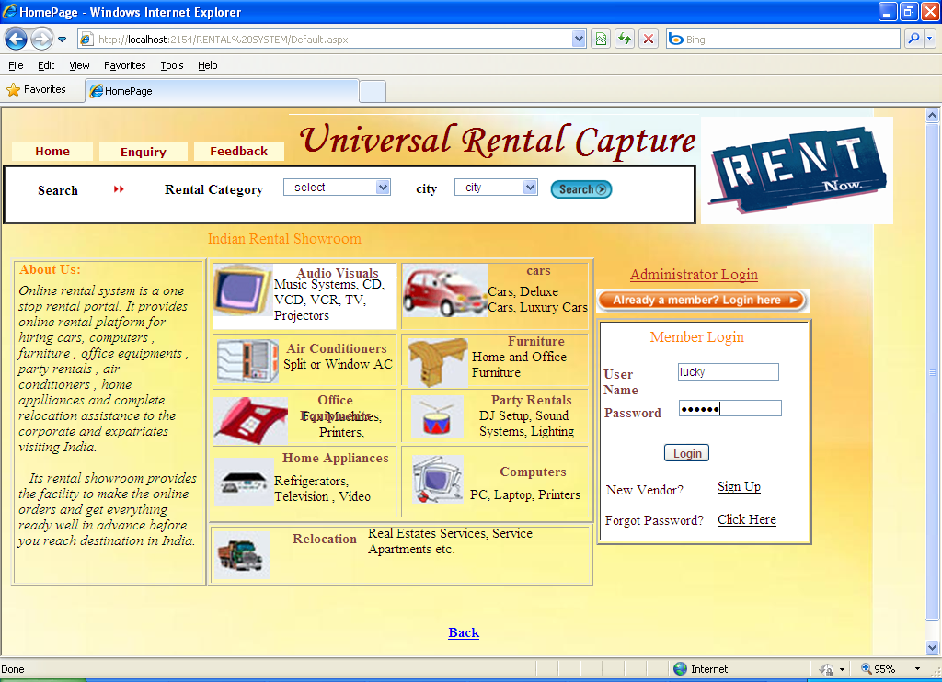

Pagename: home page

Fields: login,user,paaaword,signup,admin

Process: navigates to child pages,admin

Table: login

Remarks: enter into fields

Error: no

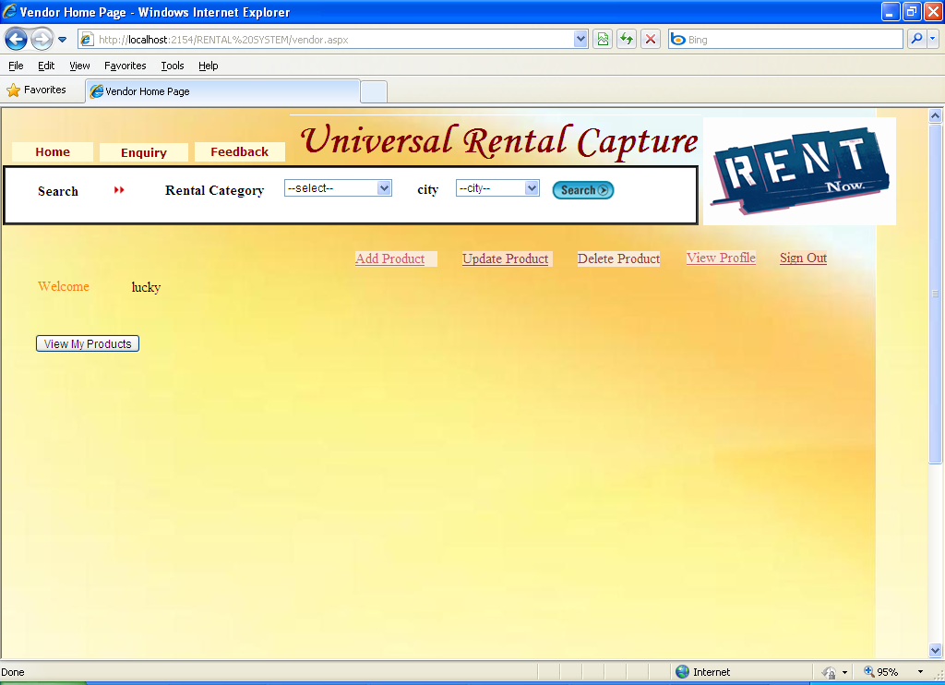

Pagename: member home page

Fields: child pages

Process: navigates to child pages

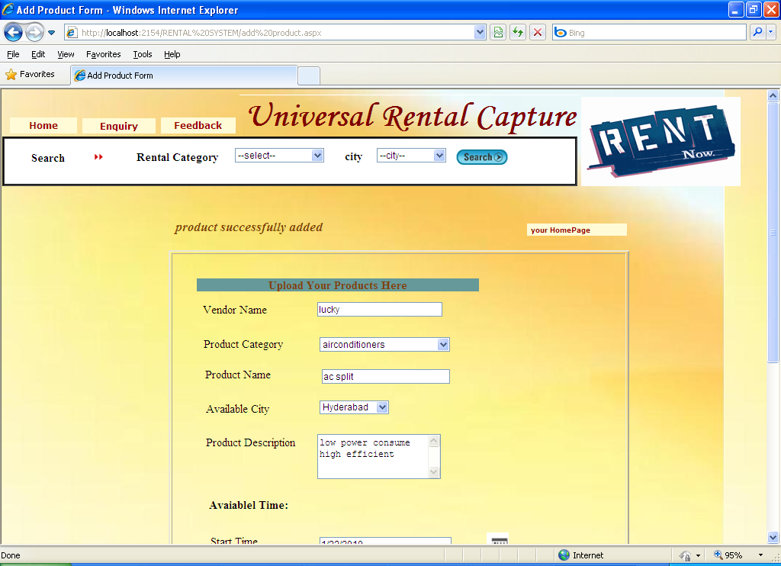

Pagename: add product

Fields: name,category,city,time

Process: we can add products

Table: products

Remarks: enter into fields

Error:no

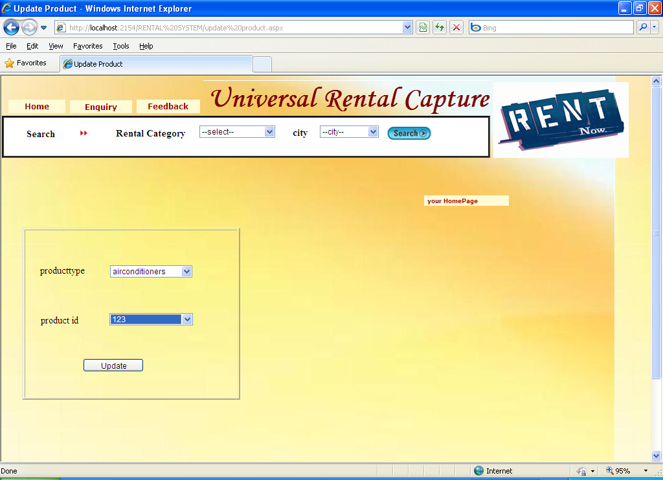

Pagename: update products

Fields: type,id

Process: cann update products

Table: products

Remarks: select

Error:no

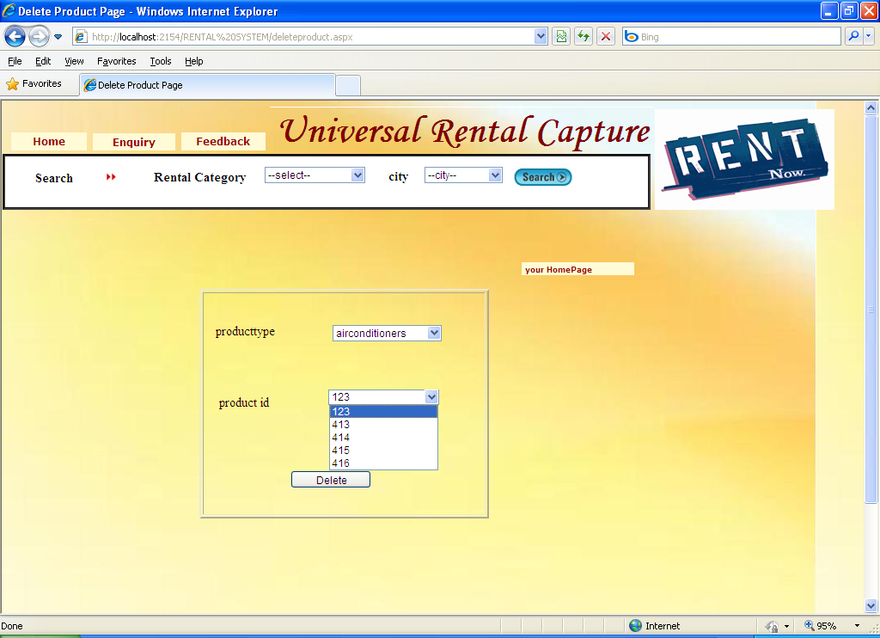

Pagename: delete products

Fields: type,id

Process: cann delete products

Table: products

Remarks: select

Error:no

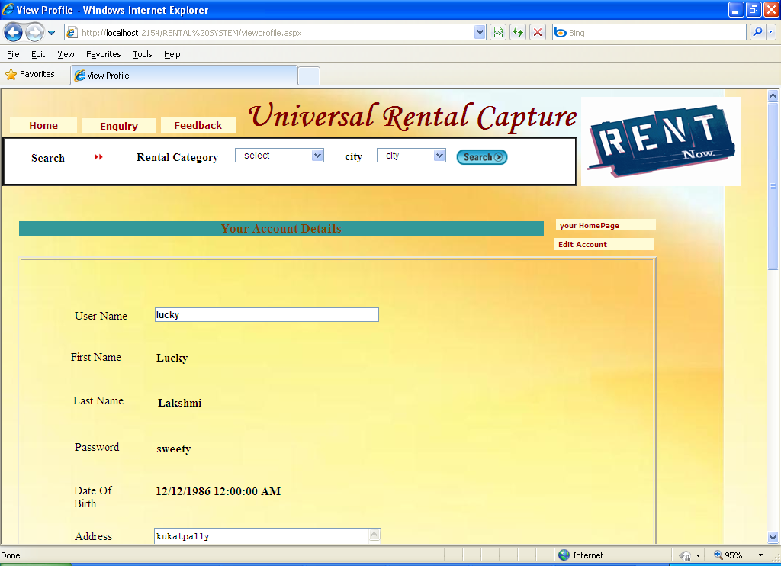

Pagename: your account details

Fields: username,name,pwd,dob,address

Process: we can view our details

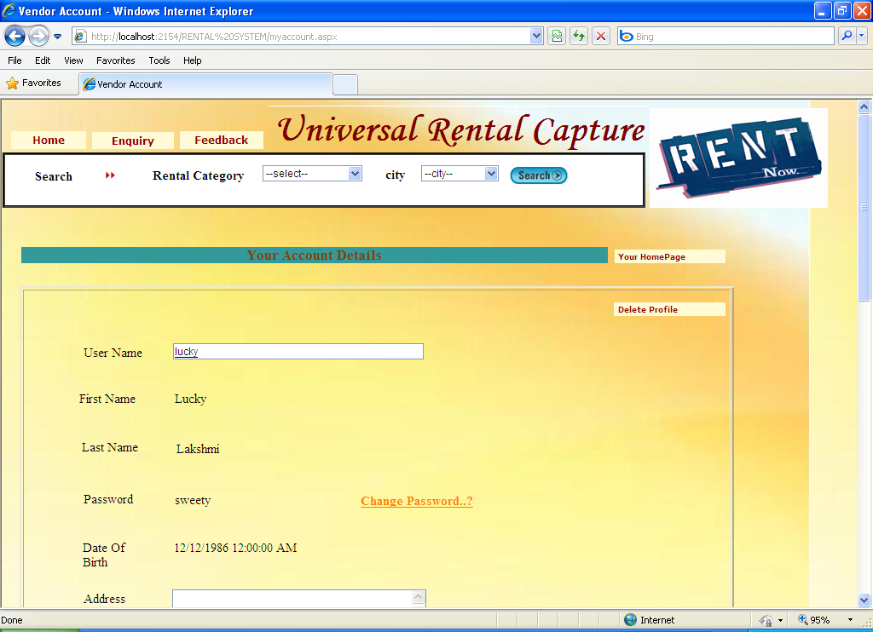

Pagename: your account details

Fields: username,name,pwd,dob,address

Process: we can view our details

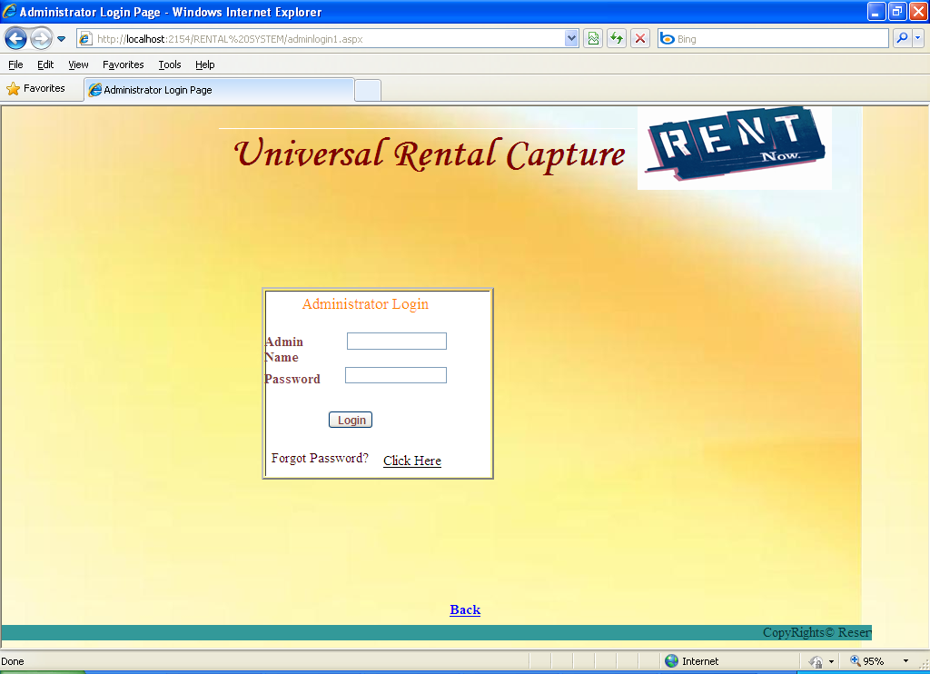

Pagename: admin login

Fields: username,password

Process: navigates to admin home page

Remarks: enter credentils

Error:no

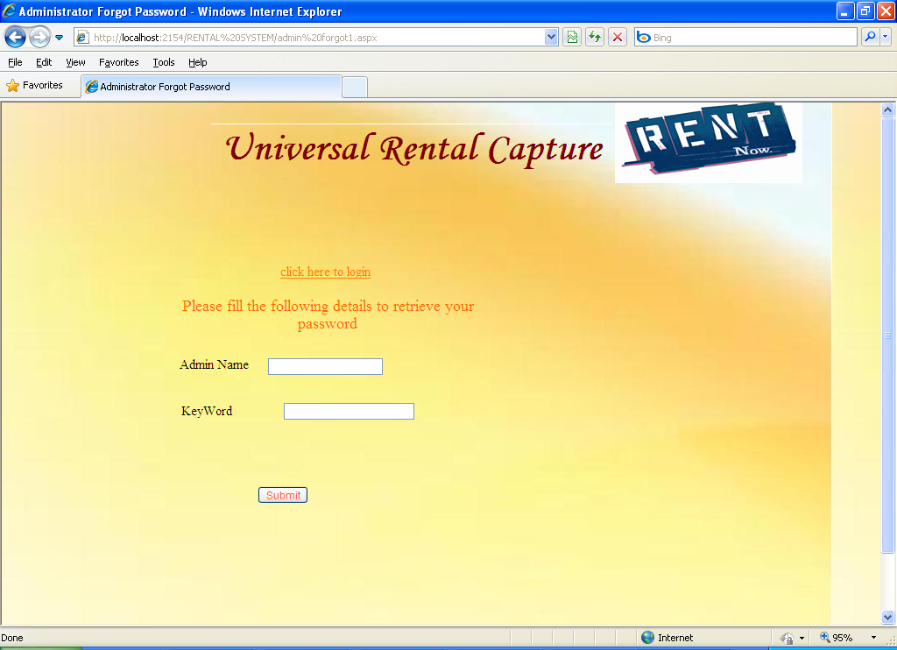

Pagename: admin forget password

Fields: admin name,keyword

Process: tells the password

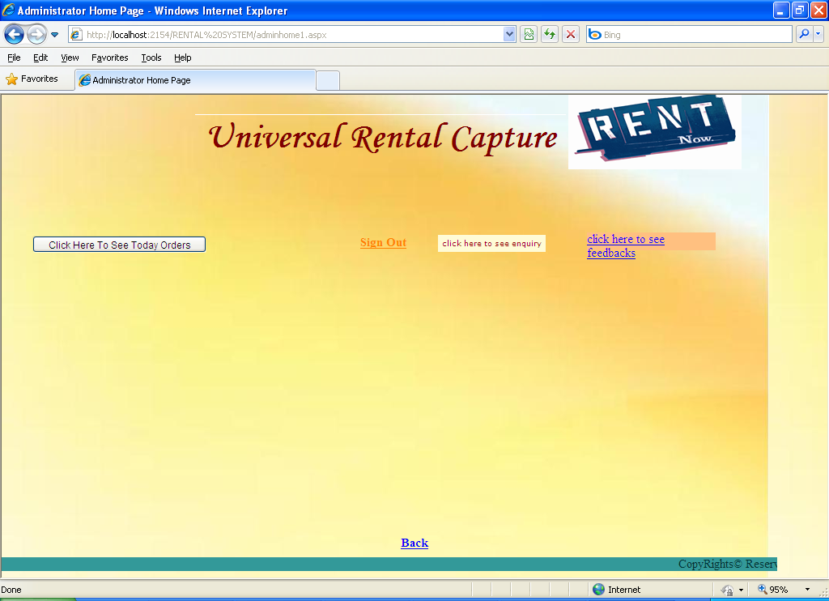

Pagename: admin home page

Fields: today orders,enquiry,feedbacks,signout

Process: can view above all

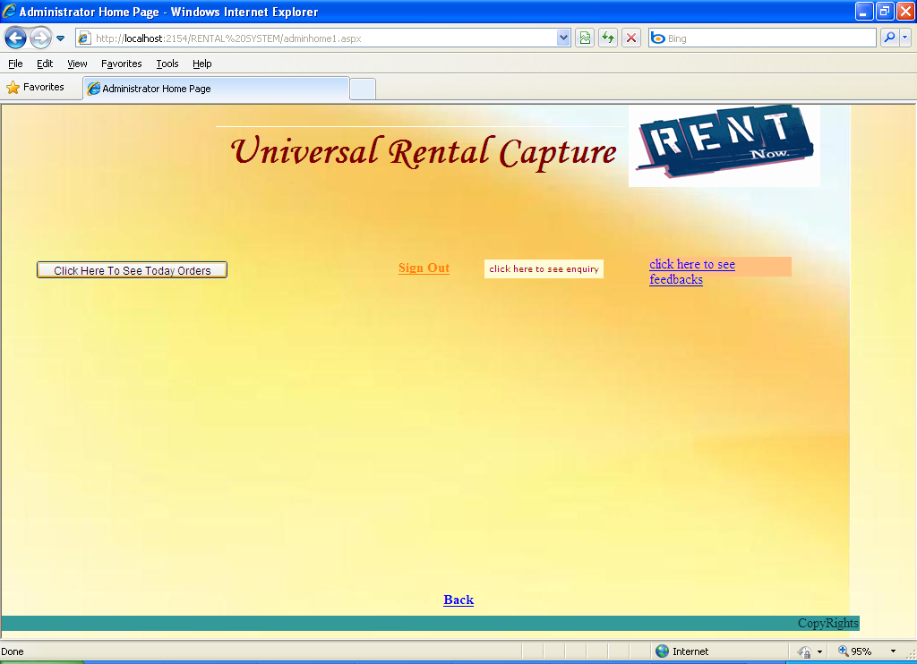

Pagename: admin home page

Fields: today orders,enquiry,feedbacks,signout

Process: can view above all

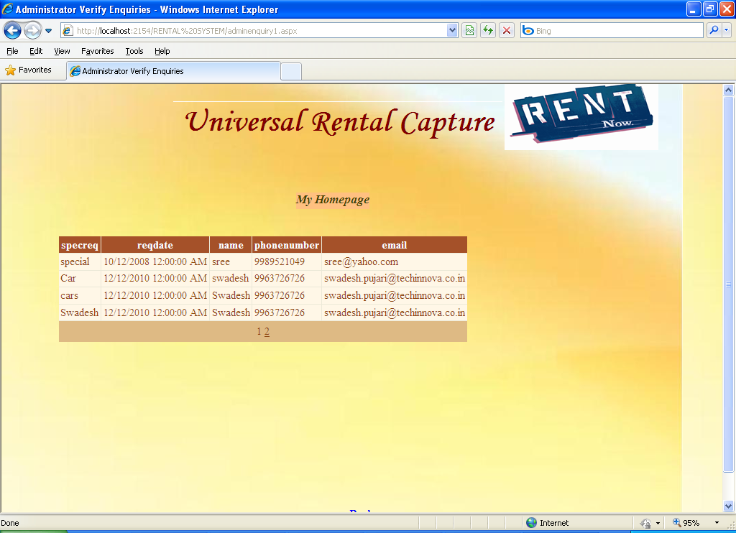

Pagename: admin home page

Fields: today orders,enquiry,feedbacks,signout

Process: can view above all

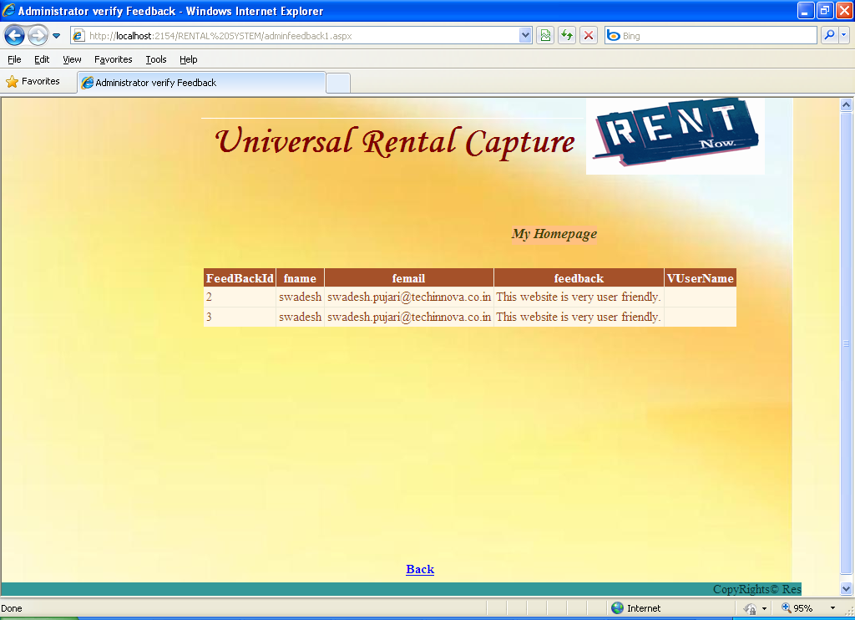

Pagename: admin home page

Fields: today orders,enquiry,feedbacks,signout

Process: can view above all

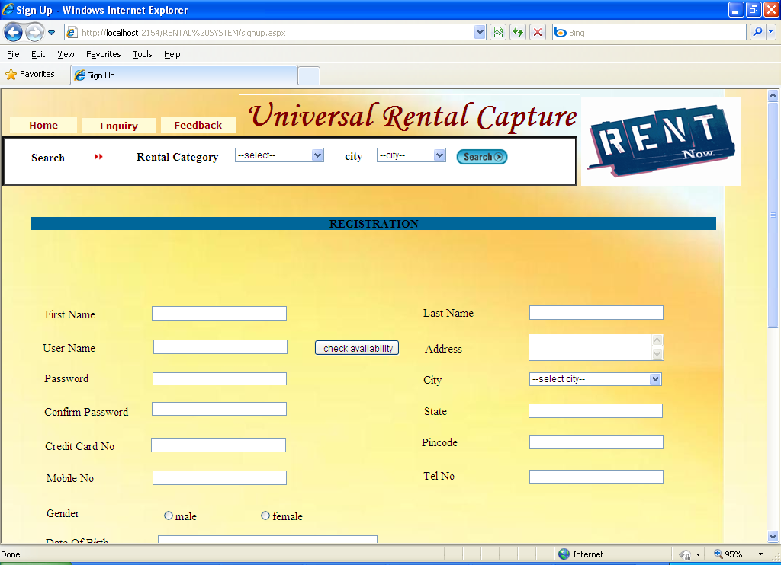

**Vendor Registration Form**

Pagename: **Vendor Registration Form**

Fields: name,username,password,address,city,state

Process: can register new vendor

Table: vendortab

Error:no

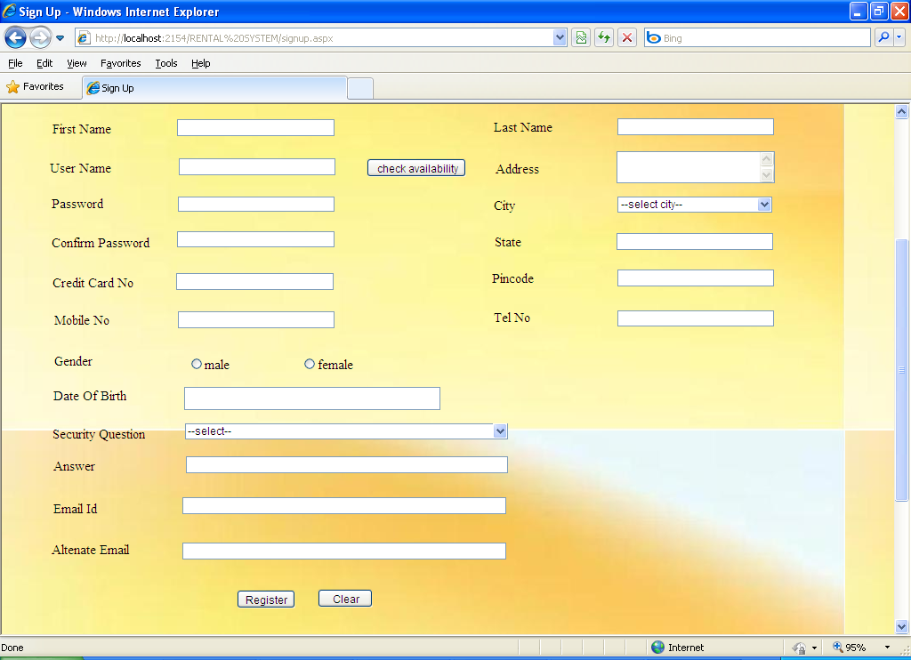

**Vendor Registration Form**

Pagename: **Vendor Registration Form**

Fields: name,username,password,address,city,state

Process: can register new vendor

Table: vendortab

Error:no